VASCULAR PLANTS (pgs -544-550)

What is the equation for photosynthesis?

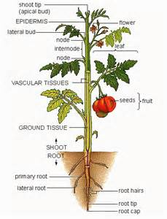
What system to leaves and stems belong to?

List the plant organs you see in the picture.

Types of Ground Tissue
Type Of Ground Tissue | Example | Functions
Parenchyma | 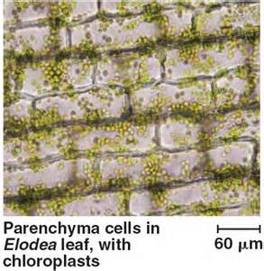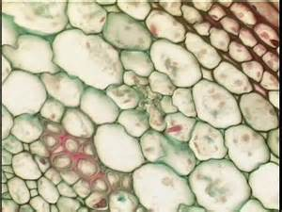
Collenchyma | 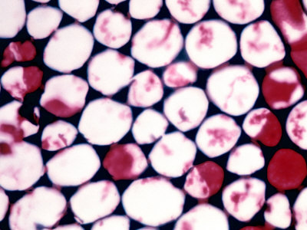
Sclerenchyma | 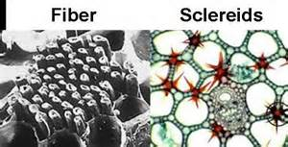
DERMAL TISSUE

A stomata is composed of cells which border a hole called a . Label these on the diagram below.

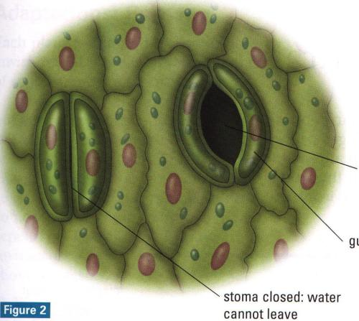
Why is it important for the stomata to be able to open and close?

Trichomes

Root hairs

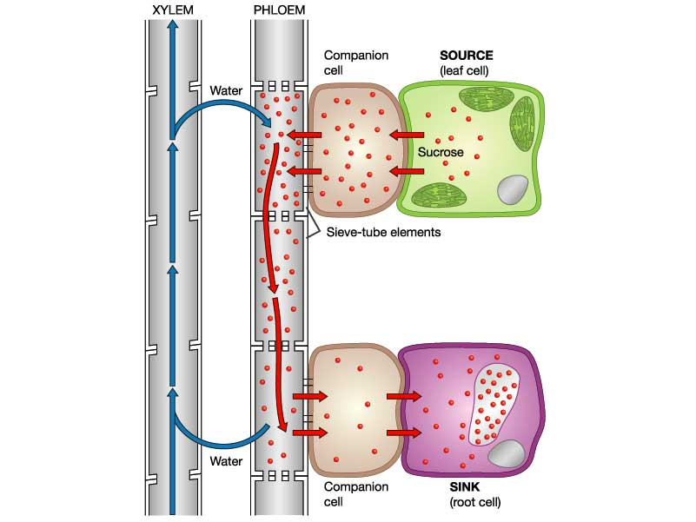
VASCULAR TISSUE

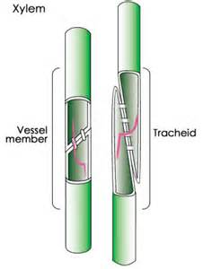
Explain how both types of tissue work. How does water from xylem help
the phloem?

Define intercalary (apical) and lateral meristematic tissue in the space below.

